**Mobile Application Development**

**Pong Assignment**

**Deadline:** 11:00 pm, Monday, 27th January

**Submission:** Google Classrooms. Upload complete project

**Marks:** 8

**Requirements (1 mark each):**  
  
1. The game will have a total of 39 blocks. Consult the mockup below. There will be 4 green blocks, 4 red ones, 9 orange ones and 22 blue ones.

2. The ball must be circle. The arrangement of the blocks must be similar to that in the mockup

3. Clearing orange block will give user 5 points. Blue will give 10 points.

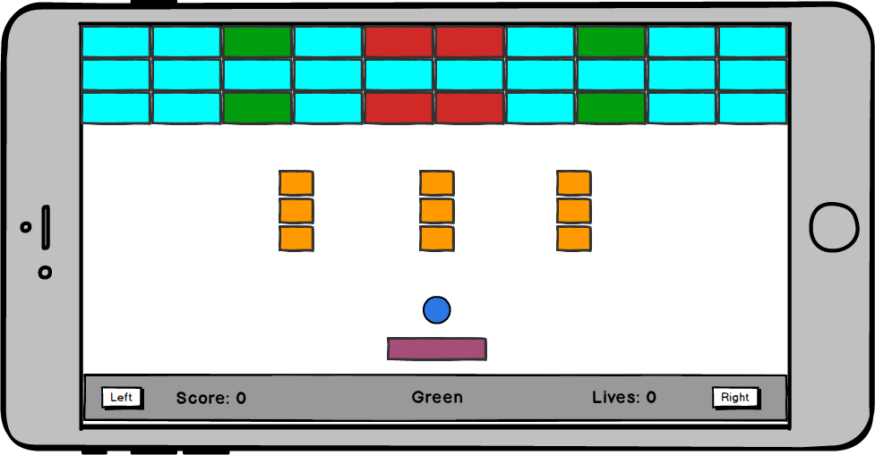

4. When the green block is hit, a power up will fall down. If user collects the power up, the size of bat will increase by 20%.

5. When the red block is hit, a bomb will be dropped. If user collects the bomb, score will reset to zero.

6. Every time the ball hits a block, the color of the ball and the “Green” text will change to the color of the block that was hit

7. The bottom panel is outside the game area. This panel will contain 2 buttons, and 3 texts as shown in mockup.

8. The bat can move only when the right, or left button is pressed. Neither ball, nor bat can go outside screen boundaries